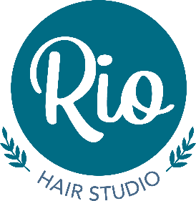
CUT & BLOW DRY
(Inclusive of shampoo & styling aid)
 | Kyleigh  Self employed | Kate | Hannah | Katie APR | Martyn  Self employed
Short | £35.50 | £33.50 | £33.50 | £22.50 | £35.50
Medium | £37.50 | £35.50 | £35.50 | £24.50 | £36.50
Long from* | £39.50 | £37.50 | £37.50 | £25.50 | £38.50
Restyle | £42.00 | £40.50 | £40.50 | £30.00 | £40.50
Wash & Cut | £23.50 | £22.50 | £22.50 | £17.50 | £23.50
Dry cuts from* | £20.00 | £20.00 | £20.00 | £15.00 | £20.00
BLOW DRY / SET
(Inclusive of shampoo & styling aid)
 | Kyleigh  Self employed | Katie | Hannah | Katie APR | Martyn
Short | £22.00 | £21.50 | £21.50 | £18.50 | £22.00
Medium | £24.00 | £23.50 | £23.50 | £19.50 | £24.00
Long from* | £26.00 | £25.50 | £25.50 | £21.50 | £26.00
COLOURING All stylists’ (depending on length)
Roots only | £40.00
Roots & ends from* | £44.00*
Full head colour from* | £56.00*
Toner from* | £17.00*
Vivid Colours | £56.00 + £10 per colour
*Prices are for one colour – multiples by quotation
** SKIN TEST REQUIRED 24-48 HOURS BEFORE **
HI / LO LIGHTS (One colour only & depending on length)
Highlights | £49.00*
Full head highlights  Back to back | £56.00*
T-section or short | £45.00
Balayage/ ombre from* | £56.00*
PERMING All stylists’
Prices start from £50.00 depending on length*
HAIR UP STYLES
Prices from £35.00 depending on length*
BRIDAL / PROM / SPECIAL OCCASION HAIR
By quotation – includes trial session

